IFT 166 Introduction to Internet Networking  
  
Lab 21

**NAT Translations**

**NOTES**

Failure to match my configuration exactly will lead to commands failing later.   
The first time I show a command I will use its full form but shorten it for ease of typing every time thereafter.

**1.** Create the configuration shown in the diagram in Cisco Packet Tracer.

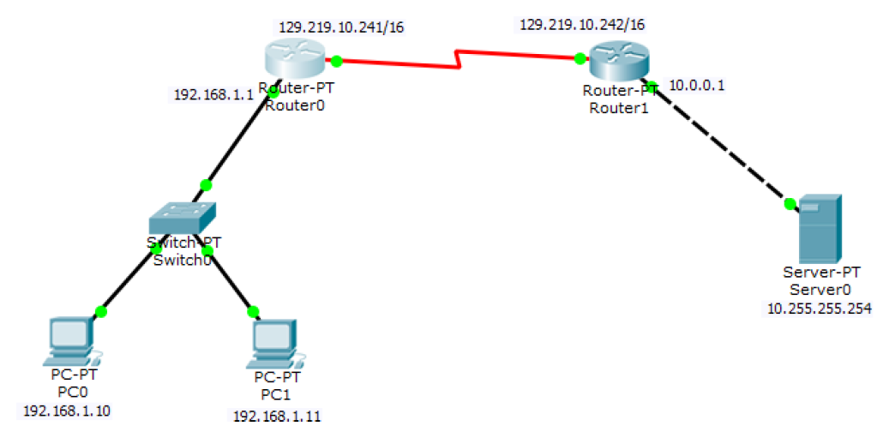

2. Verify that the HTTP service is running on your server by selecting Server0 > Services > HTTP > ON

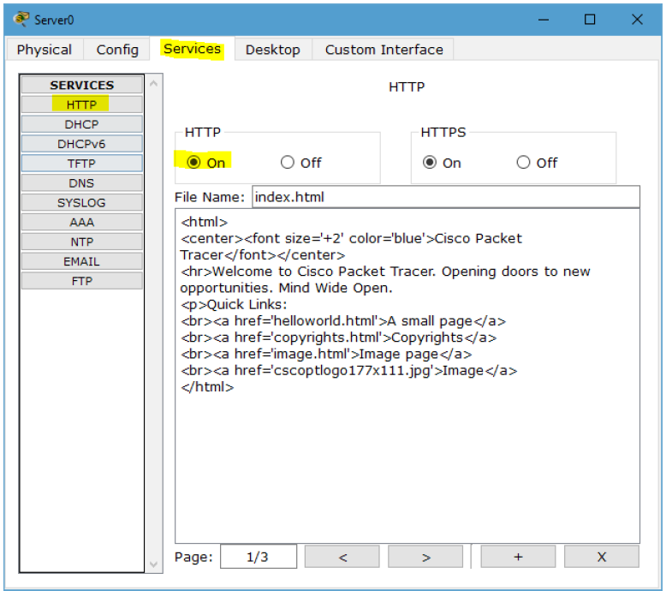



Attempt to ping the server from a PC0 or PC1. What response do you get? Ping successful

Open the web-browser of PC0 or PC1. Browse to Server0’s "internal" address (10.255.255.254). Does it work? What error do you get (if any)? Request time out

1. Let’s set each router to have a default route to the other. Open the CLI of Router0 and type the following commands

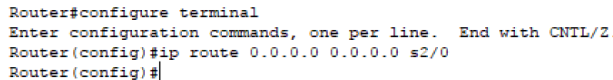

Repeat this procedure on Router1. To validate that both settings worked run a ping from PC0 to Server0.

**Do not proceed from this step until you can successfully ping.**

1. Now let's connect to the website. Open the web-browser of PC0 or PC1. Browse to Server0’s "internal" address. Does it work?

What error do you get (if any)? Request timed out

Out on the open internet we don't connect to other computers internal network addresses. So let's try the public address (129.219.10.242). Does that work? What error do you get (if any)? Request timeout

1. Enter these commands on Router 1

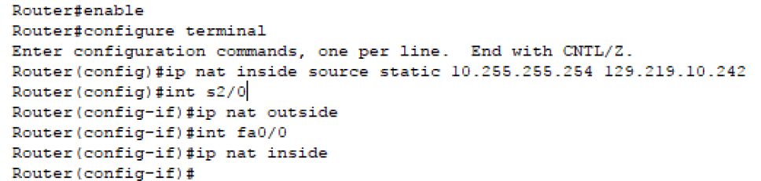

Does the public address work now? What error do you get (if any)? **None**

This is how we configure a **STATIC NAT**. We’ve told the router that all traffic coming to the router is destined to go to the server behind it. We can confirm this in the CLI by typing the following command into Router1’s CLI.

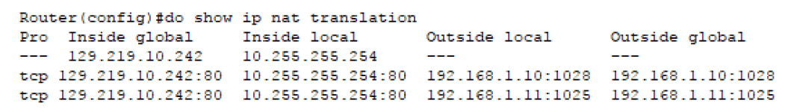

We can see the table is populated with every machine that you've connected to the server from the other network. If you have not connected from both machines, do so now and check the table again.



1. Now check the NAT table on router0. Since we haven't configured a NAT, nothing should show up.

Enter these commands on Router 0

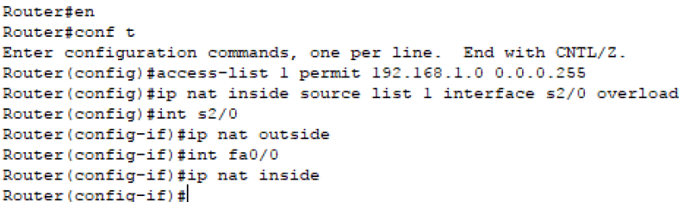

These commands make a list of internal IP addresses and tells Router0 that all the IP addresses will be allowed to translate through the router. Then we told the router which port is inside and which is outside the translation.

1. Send a ping from PC0 to the server's public address and connect to the server's website on PC1.

Check the NAT table again on Router0.



This is a **Dynamic NAT**. The router assigns ports based on the traffic it sees passing through it.

When a response is received on a port it knows who the intended recipient is because this table logged who was using which ports.

We can now properly route traffic to several computers behind the router rather than statically to only one server, but the traffic has to originate from inside the network.

1. On both PCs connect to the server’s website via the public IP Address.

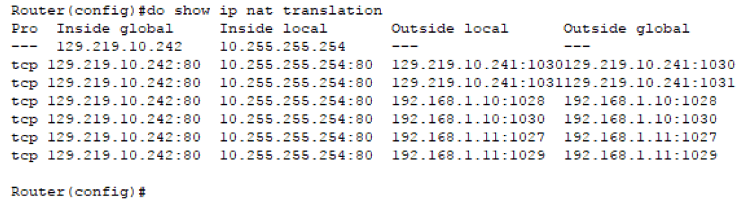

If you’ve successfully configured both the Dynamic and Static NATs you should see the external IP of the PCs show up in this table as shown above.

You should be able to compare your tables together and see ports line up to connect the internal IP of a PC# to the internal IP of Server0.

In my table above we now see 129.219.10.241 use ports 1030 and 1031 (one for each PC) when I requested new web-pages.

